Rezoon Rasheed
Project Part 2

Babson Olin FW Graduate School of Business
Modern Econometrics for Business
Spring 2025

Professor Jessica Simon

Table of Contents
Analysis 3
1.1: Multicollinearity (VIF Results) 3
1.2: Regression results 4
Discussion 4
2.1: Summary of Results 5
2.2: Linking Results to the Research Question 5
2.2.1: Research Question 1: Does distance from the CBD affect house price? 5
2.2.2: Research Question 2: Does floor area affect house price? 5
2.2.3: Insights 6
2.3: Alignment with Literature 6
2.4: Divergences and Potential Explanations 7
2.5: Limitations 7
2.6: Future research 8
Conclusions 8
Appendix A 9
Appendix B 10
Bibliography 10

Analysis
1.1: Multicollinearity (VIF Results)
Before interpreting the model, we checked whether the predictors were too closely related. Variance Inflation Factor (VIF) statistics for each explanatory variable are listed in Appendix A. VIFs for every term in the specification that regresses the log of sale price on log-distance to the central business district (lnCBD_DIST), log-floor area (lnFLOOR_AREA), log-distance to the nearest school and rail station, and the interaction between lnCBD_DIST and lnFLOOR_AREA.
The VIF diagnostics reported in Appendix A are reassuring with four of the five predictors fall between 1.08 and 3.75 which well below the established cut-off of five. The interaction term, of lnCBD_DIST and lnFLOOR_AREA, posts the highest score at 4.90, but even that remains under the warning threshold of 5, and way below the critical value of 10. As none of the value’s approach 10, which would indicate multicollinearity, it is unlikely that there would be inflated standard errors to hide real effects of the variables. The slightly higher VIF on the interaction is expected. Due to these findings, the model retains all logged predictors and the interaction term in their original form, with no additional centering, transformations, or variable deletion being required.

1.2: Regression results
The log-log model explains about 58 % of the variation in house prices, a solid fit for cross-sectional real-estate data. A 1 % increase in distance from the central business district lowers price by roughly 0.37 %, whereas a 1 % increase in floor area raises price by about 0.74 %. Homes located farther from the nearest ranked school are priced approximately 0.03 % higher, implying that prestigious schools cluster in already expensive suburbs. Each additional 1 % of walking distance to the closest train station trims price by around 0.02 %, confirming the premium buyers place on transport access. The interaction term shows that larger homes situated farther from the center lose less value per extra kilometer than smaller dwellings, indicating that buyers who trade commuting time for space still reward size. All predictors are highly significant at the 99 % level of confidence. The residual standard error of 0.296 means predicted prices typically differ from actual prices by less than 30 %, an acceptable range for hedonic pricing models.

Discussion

2.1: Summary of Results
The central research question asked how location and their attributes come together to shape Perth house prices in 2020. The estimates show that proximity to economic centers and rail infrastructure is capitalized into prices, while interior floor carries a substantial premium. This finding adds an interesting insight to the typical distance decay story, showing that the payoff from extra space shifts depending on where the home lies within the city.

2.2: Linking Results to the Research Question
2.2.1: Research Question 1: Does distance from the CBD affect house price?
H0: Distance to the CBD has no relationship with house price.
Ha: Distance to the CBD has a negative relationship with house price.
The regression for lnCBD_DIST delivers a coefficient of –0.3725, a t-statistic of –32.14, and a p-value well below 0.01. This relation suggests, every 1 % increase in distance from the CBD cuts price by 0.37 %. Pushing distance up by 10 %, about nine kilometers, cuts value by roughly 3.7 %, or about $20 000 on a $550 000 home. The effect is large and statistically strong, so we reject the null hypothesis and confirm that greater distance from Perth’s CBD lowers house prices.
2.2.2: Research Question 2: Does floor area affect house price?
H0: Floor area has no relationship with house price.
Ha: Floor area has a positive relationship with house price.
For lnFLOOR_AREA the model reports a coefficient of 0.7380, and the small p-value which is below 0.01. Interpreting the elasticity, expanding a home’s floor space by 1% raises its price by about 0.74%. Boosting floor area by 10 %, say from 150 to 165 square meters, raises price by about 7.4 %, adding roughly $40 700 to a $550 000 home. The effect is strong and statistically solid, so we reject the null hypothesis and confirm that larger interior space commands a clear premium in Perth.
2.2.3: Insights
These two hypothesis tests, combined with an overall R-squared of 0.5826 for the model, show that proximity to the CBD and generous floor space are both powerful, quantifiable drivers of residential property values.

2.3: Alignment with Literature
Urban economic theory predicts a negative coefficient between price and distance to the center because commuting costs rise with distance. Recent empirical work reports coefficient of -0.40, with a value close to our estimate of -0.37 (Yuer et al., 2019). The floor-area with the value of 0.74 indicates a positive relationship between living space and property value found, backed by the finding of Dortmund case study (Dirk et al., 2020), established that each additional square meter of living space depicted a positive correlation with price.
The high negative coefficient on school distance in results from Brisbane with a value of -0.11, accounting for only top-ranked schools command a strong price premium (Gono et al., 2020). Without direct quality measures in our dataset, distance may be influenced by other factors driving the variable into a positive coefficient, with a value of +0.03.

2.4: Divergences and Potential Explanations
The were some results that stood out compared to patterns reported in the work we cited. The coefficient on school distance is positive (+0.03) was a surprise as by contrast Shishir (2022) documented a weakly monotonic or even non-linear link between school quality and house prices. Because our data include distance but not sufficient data on quality scores, the positive sign may be picking up the Brisbane layout where high-performing schools are already located in expensive suburbs. In other words, houses that are just a bit farther from a top ranked school often come with bigger yards or sit in more upscale areas, so their prices can go upward instead of falling.
Unmeasured neighborhood amenities such as beaches, rivers, or retail trends, could also distort distance effects, as Xiang et al. (2024) note when they show that better accessibility does not always push prices higher. Without spatial fixed effects, such omitted factors may partly drive the divergences we observe.

2.5: Limitations
Single-year data: Due to analysis covering only 2020 sales, it does not capture how prices move over multiple economic cycles, so the findings may not hold in influence over time.
School quality: Using distance alone to stand in for school quality risks mis-measuring the true effect, since a farther school can sometimes outperform a closer one if its better in quality, influencing the target.
Missing lot size and bathrooms: Without these variables, their influence is rolled into the floor-area coefficient, which would likely overstate the value buyers place on interior living space alone.
2.6: Future research
With richer data we could add detailed school quality scores and measured lot size, giving a clearer view of how education and land drive prices. Building a time series model so see the difference in market over time, making it more useful. Finally, exploring nonlinear interactions between distance and house size could reveal threshold effects that the current linear specification may miss.

Conclusions
In Perth’s property market, where a house is situated and how much floor area it offers, work together to set its price. Houses located farther from the CBD sell for less, while extra square meters and easy access to rail stations tend to push prices up. The results also reveal that large houses on the outskirts take a smaller price hit, reflecting how buyers weigh extra space against a longer trip into town. The estimates are explaining more than half of the variation in sale prices, but there are also some areas for improvement by adding detailed data, which could include more detailed interior floor areas, school rankings, and other amenities to aid planners and buyers to make a sound decision.

Appendix A

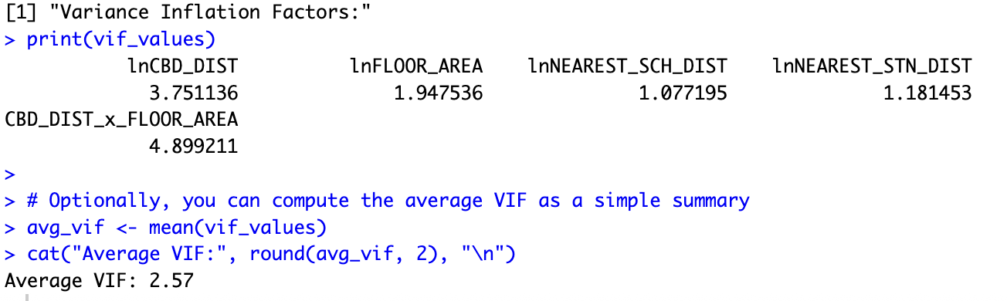

Appendix B

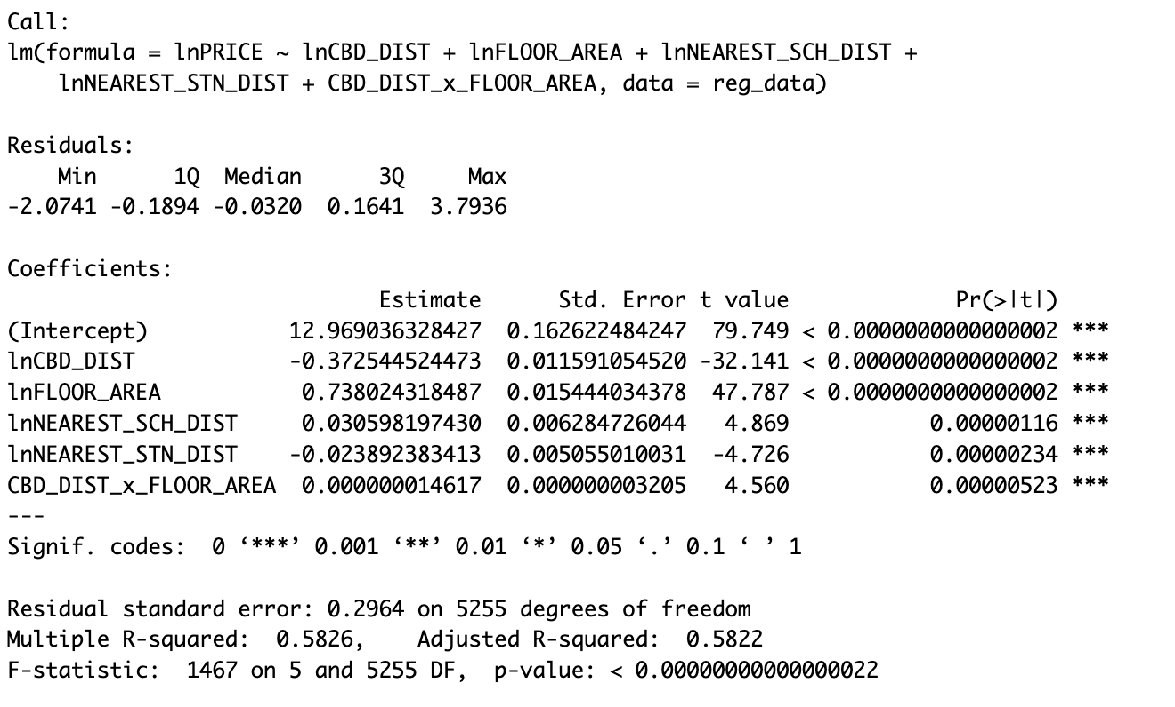

Bibliography

Dirk, W., Josje, H., Janina, W., & Michael, S. (2020). Residential housing prices: impact of housing characteriﬆics, accessibility and neighbouring apartments – a case ﬆudy of Dortmund, Germany. Urban, Planning and Transport Research.
Gono, M., Rajapaksa, D., Clevo, W., Shunsuke, M., Boon, L., & Viet-Ngu, H. (2020). The demand for education: The impacts of good schools on property values in Brisbane, Australia. Land Use Policy.
Shishir, M. (2022). Non-linear and weakly monotonic relationship between school quality and house prices. Land Use Policy.
Tao, X., Ming, Z., & Paulus, T. A. (2016). The impact of urban rail transit on commercial property value: New Evidence from Wuhan, China. Transportation Research Part A Policy and Practice .
Xiang, L., Xiaohong, C., Scott, O., Mingshu, T., & Guojian, Z. (2024). Does better accessibility always mean higher house prices? Urban Analytics and City Science.
Yuer, C., Maziar, Y., Mohammad, M., & Sidney, N. (2019). The impact on neighbourhood residential property valuations of a newly proposed public transport project: The Sydney Northwest Metro case study. Transportation Research Interdisciplinary Perspectives.

